# Scope

This procedure describes the calibration of a temperature probe and transmitter by direct comparison against a calibrated standard in a temperature controlled block calibrator.

# Applicability

This procedure is applicable to the calibration of temperature probes with transmitters, from 0 to 100°C, with an uncertainty of approximately ± 0.2°C.

It is suitable for probes and transmitters intended for use with the FCO510 or FCO560.

# Definitions

PT100 A PRT with a resistance of 100 Ω at 0°C.

RS232 Recommended Standard 232. A digital communications standard for serial binary data signals (not to be confused with the RS identification numbers for laboratory equipment).

RS422 Recommended Standard 422.

# Abbreviations

CS043 Company Software 043;

CS072 Company Software 072;

EUT Equipment Under Test;

PRT Platinum Resistance Thermometer

RTD Resistance Temperature Detector (Resistance thermometer)

# Documents Required

Euramet Calibration Guide No.13 V4.0 (09/2017)

EA-10/13 EA Guidelines on the Temperature Block Calibrations

Temperature Calibrations With Isotech Block Calibrators

# Equipment Required

Standard temperature probe and transmitter (calibrated as a unit);

Validation temperature probe and transmitter (calibrated as a unit);

Either FCO560

Or 24V Supply;

FCO560;

Agilent DMM;

RS232 connector cables as required;

Computer running CS043.

# General

## Block Calibrator and Oven

The Block Calibrator consists of a temperature controlled chamber enclosing an aluminium block. The temperature changes in the block as the axial distance changes so care must be taken to ensure that the insertion depth of the probes does not exceeds 20 mm from the bottom to ensure that the temperature gradients within the block are minimised.

In general:

a) the reference probes and the EUT should be at the same depth,

b) the hole clearance should be about 0.2 mm.

c) The thermometer with a protective tube of outside diameter d ≤ 6 mm should be used.

Various inserts are available to suit different sized probes.

**Stabilisation:** In the temperature range 0 to 100 °C the stabilisation time for block calibrator is **30 minutes**.

The Oven works similarly, but allows for the calibration of remote sensors as well. If calibrating a temperature probe, an Aluminium block with bores of varying depths should be used.

**Stabilisation:** In the temperature range 0 to 50 °C the stabilisation time for block calibrator is **3 hours**.

## Default Calibration Points

**Block Calibrator:**

* 0-50°C: 0°C, 10°C, 20°C, 35°C, 50°C, 20°C
* 0-100°C: 0°C, 20°C, 50°C, 100°C, 20°C

**Oven:**

* 5-50°C: 5°C, 10°C, 20°C, 35°C, 50°C, 20°C
* 10-30°C: 10°C. 20°C, 30°C, 20°C

**Block Calibrator or Oven:**

* Room Temperature Sensor: 10°C, 15°C, 20°C, 25°C, 30°C, 20°C

# Calibrating PRTs+Xtmtr in Block Calibrator

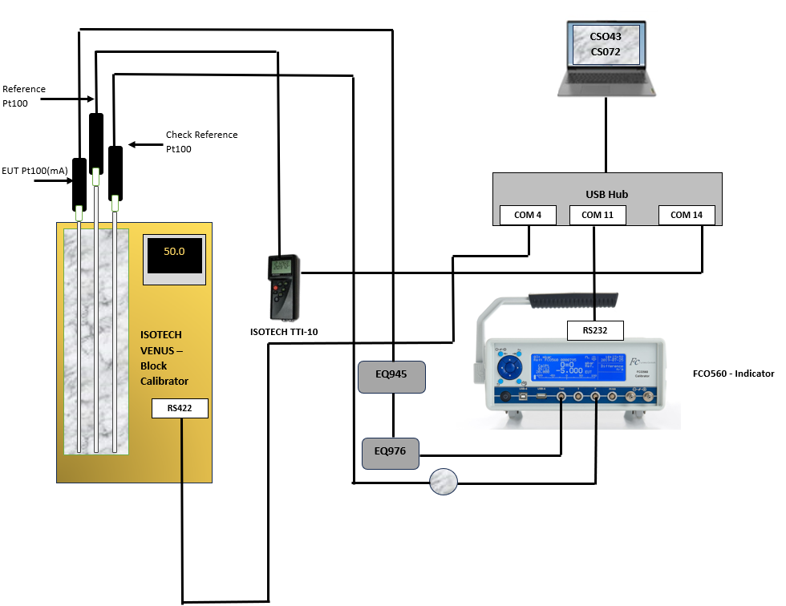

Figure 1: Calibrating a PRT+Xtmtr

## Block Calibrator Diagrams

Figure 2: Calibrating a PRT/PRT+Xtmtr using an Agilent

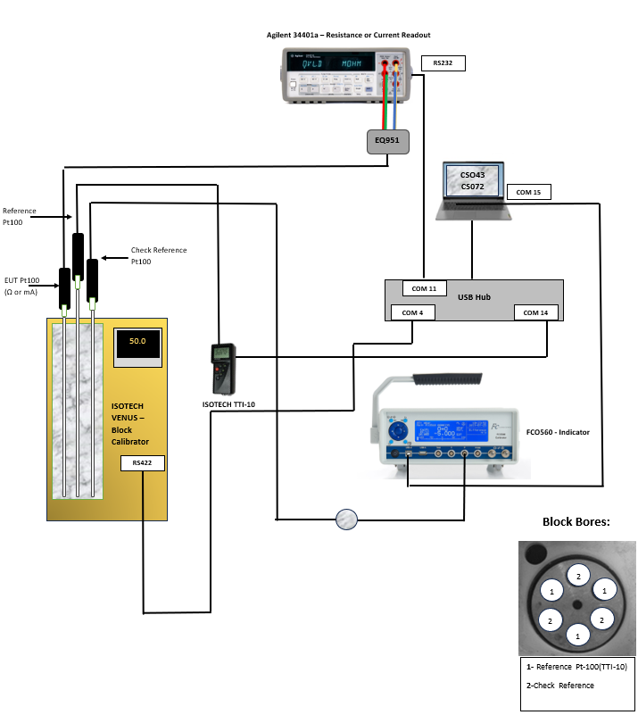

## Block Calibrator Setup

**Setup:**

* Connect RS80 PRT Reference probe via USB to the Datahub.
* Connect Check Reference PRT to the FCO560 Pressure Port and connect the FCO560 via RS232 to the laptop.
* On the FCO560, press the centre button to go to Main Menu/Pressure Sources. Select the Check PRT being used (add the PRT being used if this has not already been done so) and set the temperature values @4mA and @20 mA. Navigate to Main Menu/Aux. Signals, and set the Aux.Press to the Check PRT being used.
* Insert the EUT into the aluminium block so that the tip of the probe is at the same depth as the Reference probe.

**If using an Agilent:**

* Connect the Agilent via RS232 to the Datahub
* Connect EUT to the Agilent using EQ951 Adaptor.
* Connect the **Red** and **Green** wires to the 4W Sense/Ratio Ref HI and LO ports. Connect the **Yellow** and **Blue** wires to the Input V HI and LO ports on the Agilent.

# Calibrating PRTs and PRT+Xtmtrs in Oven

## Oven Diagrams

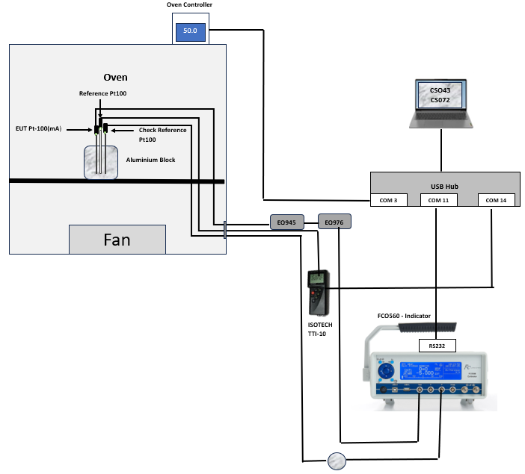

Figure 3: Calibrating a PRT+Xtmtr

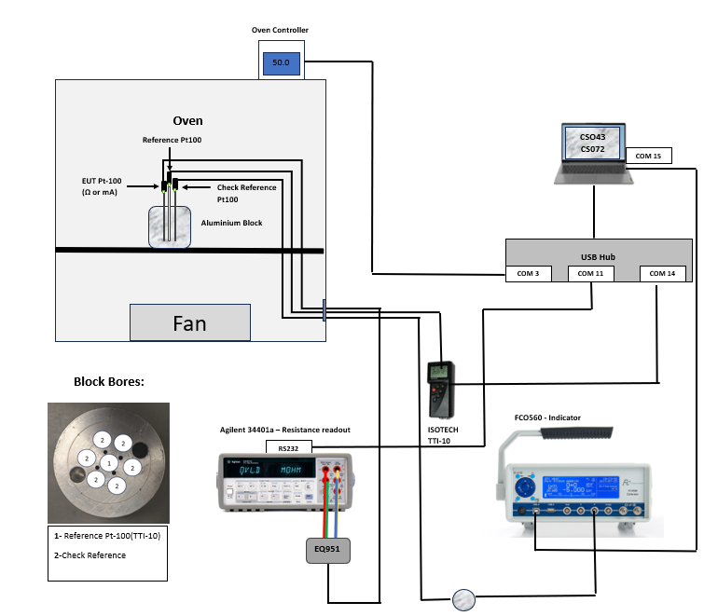

Figure 4: Calibrating a PRT/PRT+Xtmtr using an Agilent

## Oven Setup

**Setup:**

* Connect RS80 PRT Reference probe via USB to the Datahub.
* Connect Check Reference PRT to the FCO560 Pressure Port and connect the FCO560 via RS232 to the laptop.
* On the FCO560, press the centre button to go to Main Menu/Pressure Sources. Select the Check PRT being used (add the PRT being used if this has not already been done so) and set the temperature values @4mA and @20 mA. Navigate to Main Menu/Aux. Signals, and set the Aux.Press to the Check PRT being used.
* Insert the EUT into the aluminium block so that the tip of the probe is at the same depth as the Reference probe. Pass the EUT leads through the oven access hole.

**If using an Agilent:**

* Connect the Agilent via RS232 to the Datahub
* Connect EUT to the Agilent using EQ951 Adaptor.
* Connect the **Red** and **Green** wires to the 4W Sense/Ratio Ref HI and LO ports. Connect the **Yellow** and **Blue** wires to the Input V HI and LO ports on the Agilent.

# Remote Temperature Sensors

# Measurement using CS072 and CS043

To begin the temperature calibration run, open CS043, fill in the serial number and use the settings below based on the setup used:

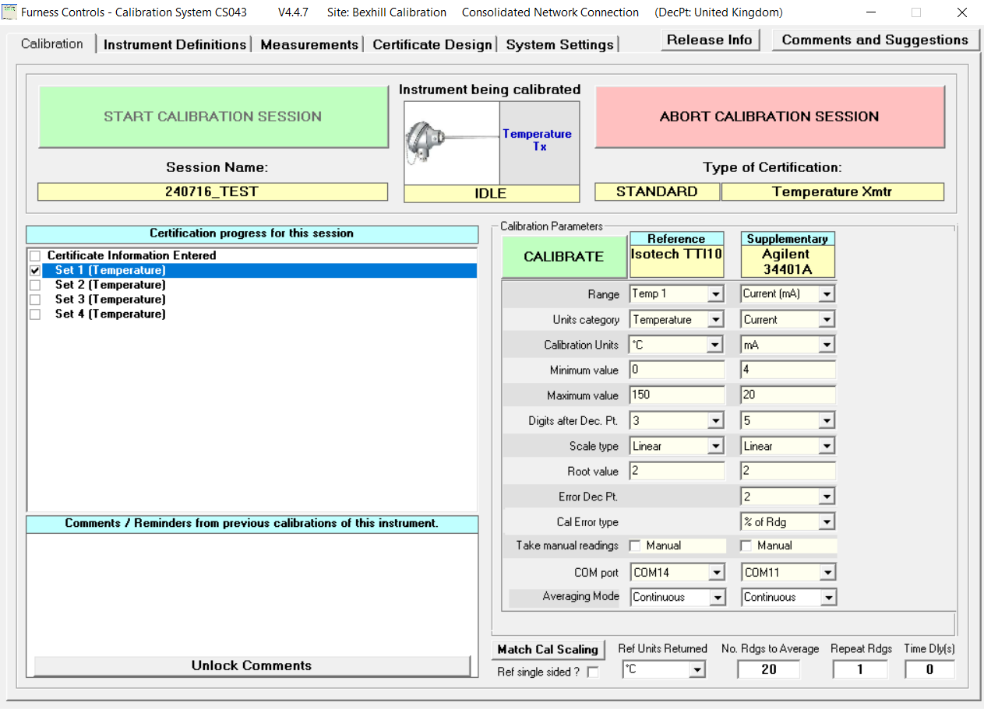**mA ouput (Agilent):**

**mA ouput (FCO560 or Agilent):**

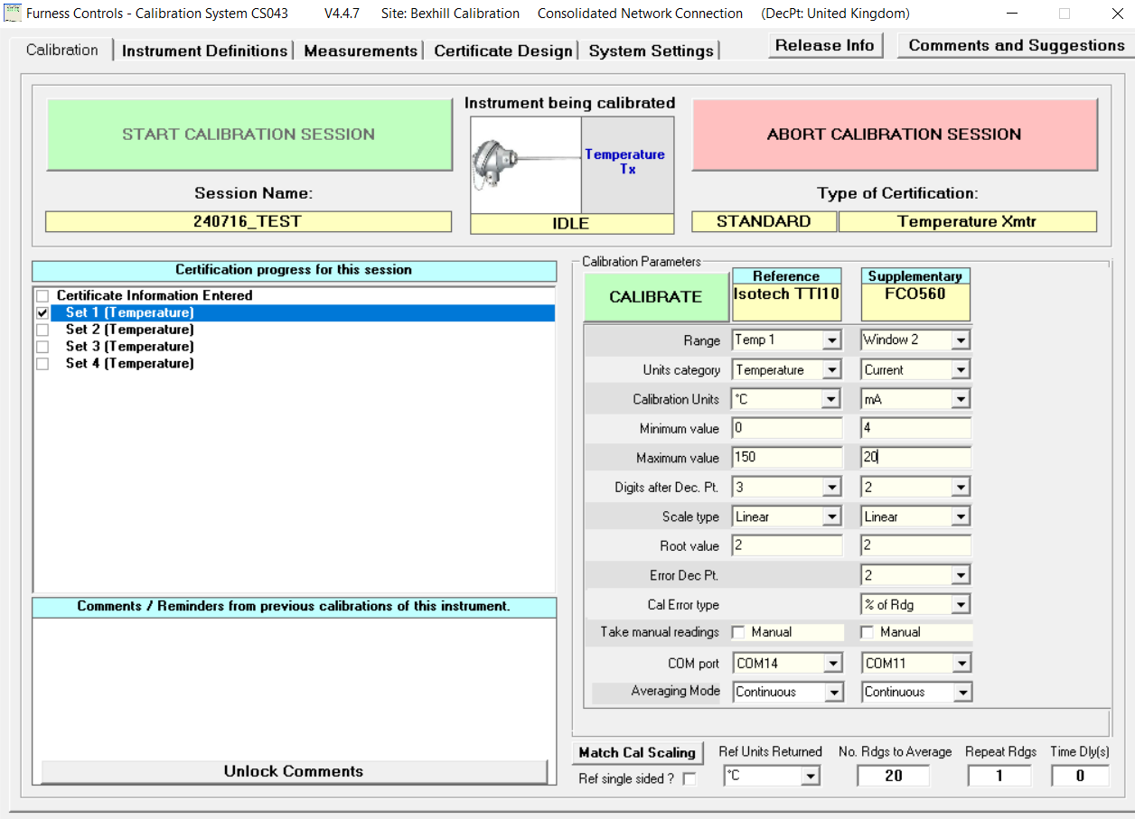

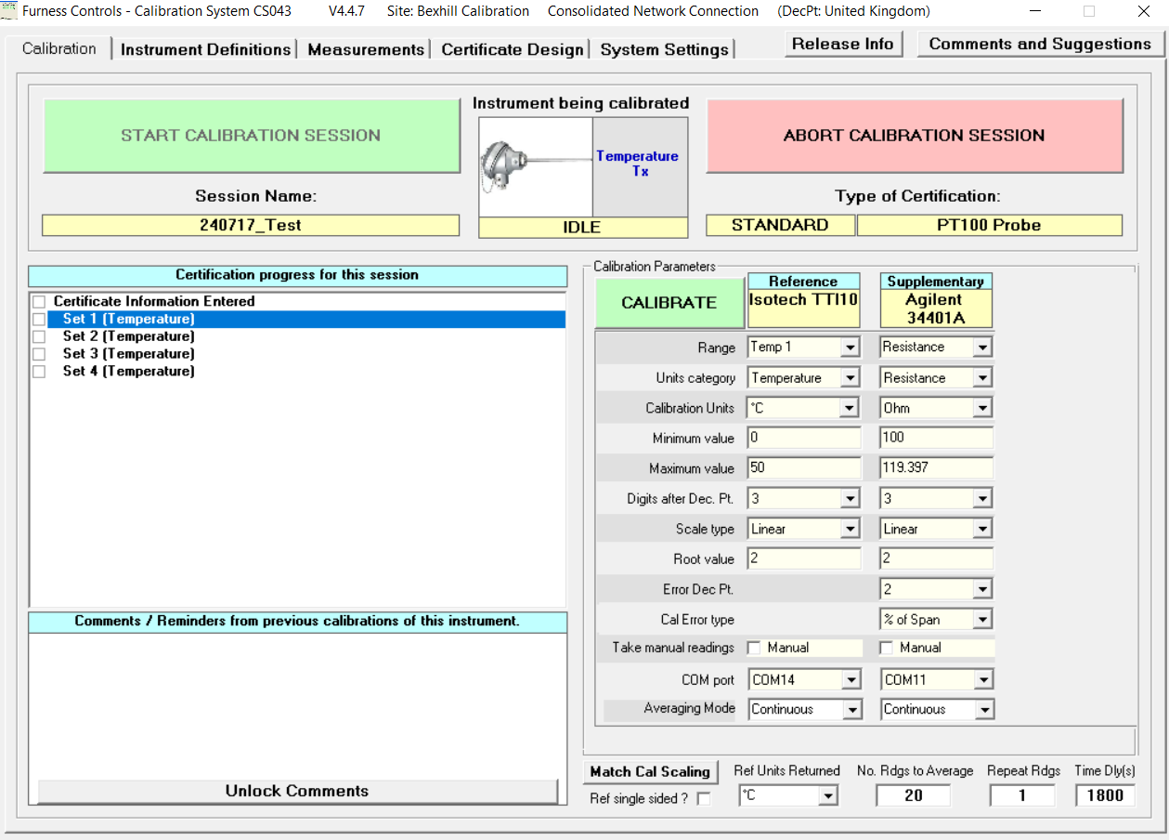

* Select ‘Calibrate’ and ensure that the “Take Readings” button window is open.
* Open CS072using the shortcut on the Desktop.
* Select the save location and name the CSV file as **yymmdd_serialno** and run the program. Choose the relevant setup and temperature profile.
* 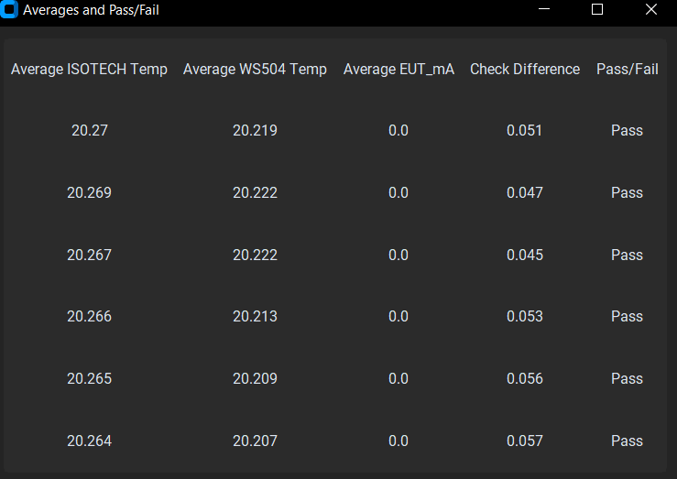Click Run on CS072 and allow the program to cycle through all the temperatures. At the end of the run, the window below will appear:
* Ensure that all Check Differneces have passed (the difference is calculated as Ref Temp – Check Ref Temp, which must be less than or equal to 0.1°C).
* Notify the cal lab manager if this is not the case.
* Generate the Excel Label.

**If PRT + Xtmtr(mA):**

* Opens CPS226. Go to the “Bestfit and Label” sheet, remove any hysteresis readings and type the output @4 and 20 mA into the next results sheet on CS043. Copy the results to this sheet.

**If PRT (Ω):**

* Opens CPS224. Type the new R0 value into the next results sheet on CS043. Copy the results to this sheet.

# Appendix

## Setting Temperatures and Time Intervals

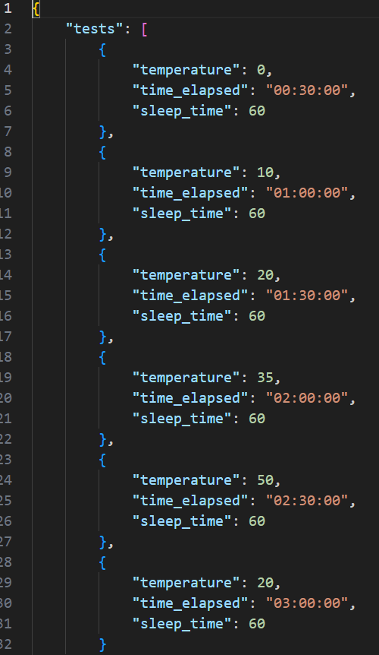The temperature values, interval times and delay times are taken from a .json file. Below is an example for the Block calibrator:

Figure 7 Example of a Block Calibrator .json file

If using the Block Calibrator only 0°C, 10°C, 20°C, 35°C and 50°C can be set currently. However if using the Oven, any temperature value can be set.

**N.B. Block Calibrator-** If other temperatures are required, the relevant

commands will need to be added to the code base.

If using the Oven, the permissible temperature range is **5-50°C.**

**AMENDMENT RECORD**

|  |  |  |  |
| --- | --- | --- | --- |
| **Issue No** | **Date** |  | **Issued by** |
|  |  |  |  |
| 01 | 2024-07-17 | First issue | R.Dabawala |
|  |  |  |  |

**DISTRIBUTION LIST**

**Head of Calibration FCL Bexhill**

**Service Manager FCL Tamworth**

**Service Manager FC Sarl France**

**Service Manager FC GmbH Germany**